**Low-fidelity Prototype**



**Description**

**Login Page** - The authentication Page where all users will be directed to get full access to the web app. You can either login as a student/faculty, admin, or restaurant.

**Home Page** - This page is the main page for navigation to other pages and also displays the restaurants available for order selection.

**Order Page** - This page is where all the ordering functionalities take place for students and faculties and will be done in a series of order pages.

**Review Page** - This page is where all the review functionalities takes place and also will be done in a series of review pages.

**Restaurant View** - Restaurant members are directed to this page after successful authentication on the login page. Restaurant staff can view orders and restaurant managers will be able to update the order item stock using this page.

**Admin View** - This is where the main monitoring of the page happens with graphs to display user interactions with CenEats.

**User Stories**

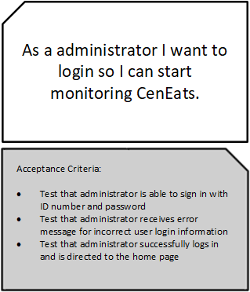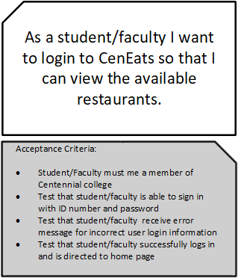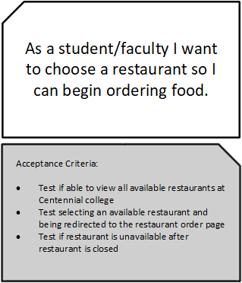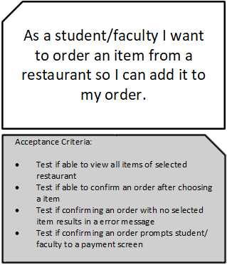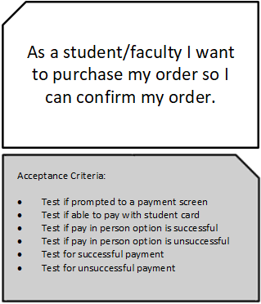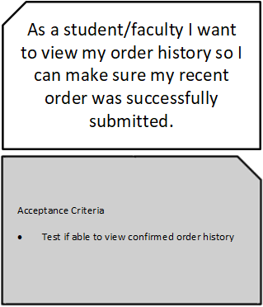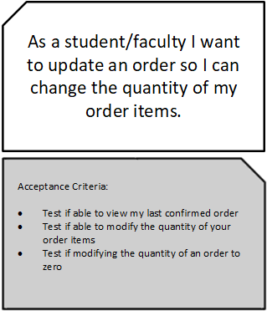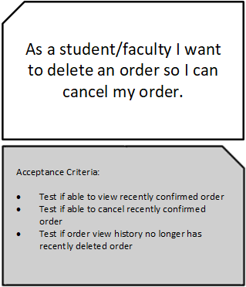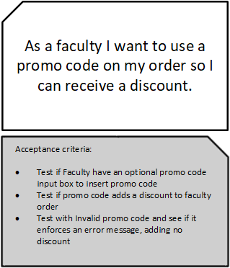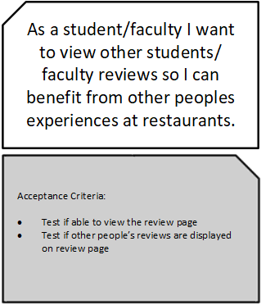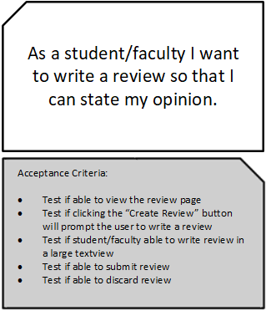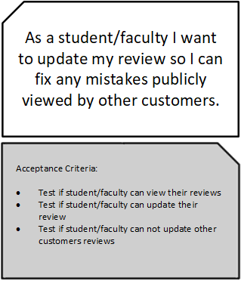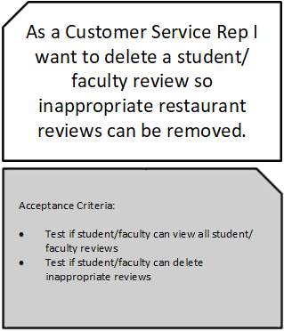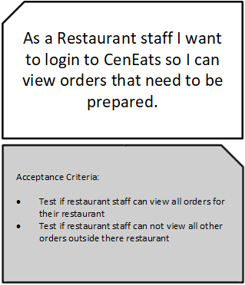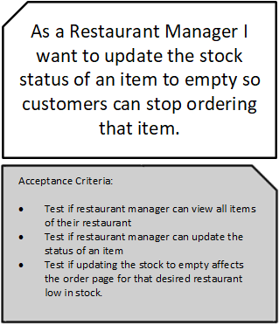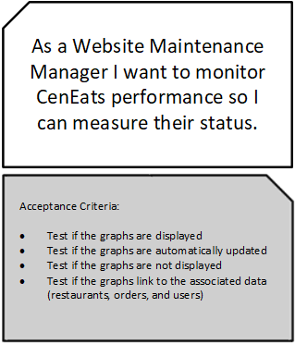

**Estimating User Stories**

Here we have estimated our user stories from a weight of 1 to 5, where 1 is considered easy and 5 is most difficult.

|  |  |
| --- | --- |
| Story | Estimate |
| As a student/faculty I want to login to CenEats so that I can view the available restaurants. | 2 |
| As a administrator I want to login so I can start monitoring CenEats. | 2 |
| As a student/faculty I want to choose a restaurant so I can begin ordering food. | 1 |
| As a student/faculty I want to order an item from a restaurant so I can add it to my order | 4 |
| As a student/faculty I want to purchase my order so I can confirm my order. | 2 |
| As a student/faculty I want to view my order history so I can make sure my recent order was successfully submitted. | 2 |
| As a student/faculty I want to delete an order so I can cancel my order. | 2 |
| As a student/faculty I want to view other students/faculty reviews so I can benefit from other peoples experiences at restaurants. | 2 |
| As a student/faculty I want to write a review so that I can state my opinion. | 3 |
| As a Customer Service Rep I want to delete a student/faculty review so inappropriate restaurant reviews can be removed. | 2 |
| As a Restaurant staff I want to login to CenEats so I can view orders that need to be prepared. | 4 |
| As a Restaurant Manager I want to update the stock status of an item to empty so customers can stop ordering that item. | 5 |
| As a student/faculty I want to update an order so I can change the quantity of my order items. | 3 |
| As a faculty I want to use a promo code on my order so I can receive a discount. | 3 |
| As a student/faculty I want to update my review so I can fix any mistakes publicly viewed by other customers. | 3 |
| As a Website Maintenance Manager I want to monitor CenEats performance so I can measure their status. | 5 |